**Project Report**

**Bankruptcy Prediction**

**TEAM 3**

**Team Leader:**

G Pranava Sai 21R11A0515

**Team Members:**

A Harshith Sai 21R11A0504

G Harshit 21R11A0519

P Rohith 21R11A0537

**Exploratory Data Analysis**

1. **Count of Bankrupt**

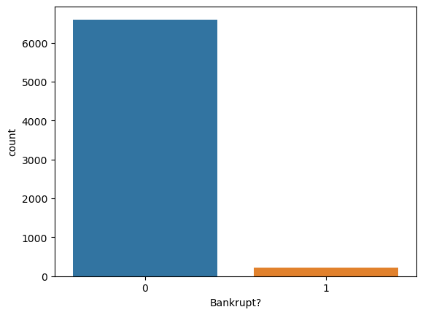

**Observation:**

* The graph represents two categories: “0” and “1.”
* The majority of data points fall under category “0,” which likely corresponds to non-bankrupt entities of count upto 6000.
* A smaller number of data points are categorized as “1,” indicating bankrupt entities.

**This distribution suggests a clear disparity, with non-bankrupt entities outweighing bankrupt ones in the dataset. Consequently, it can be inferred that the dataset is skewed towards non-bankrupt entities, indicating a potential class imbalance that should be considered in any subsequent analysis or modeling efforts.**

**2.QUICK ASSETS /TOTAL ASSETS DISTRIBUTION**

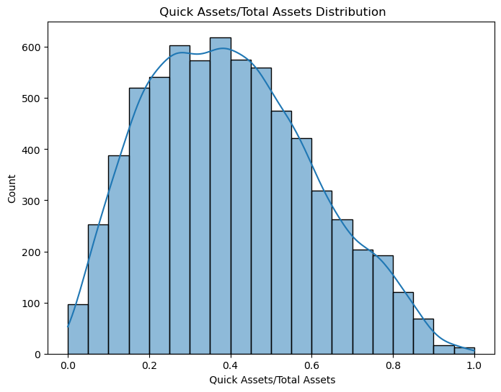

**Obsevation**:

* The histogram demonstrates a right-skewed distribution.
* A prominent peak is observed within the 0.4 to 0.6 range for the Quick Assets/Total Assets ratio.
* Entities with ratios below 0.4 may encounter challenges in meeting immediate financial needs, suggesting lower liquidity levels.
* Conversely, entities with ratios surpassing 0.6 likely possess strong liquidity positions, enabling them to readily cover short-term obligations.

**3.Operating Expense Rate Distribution**

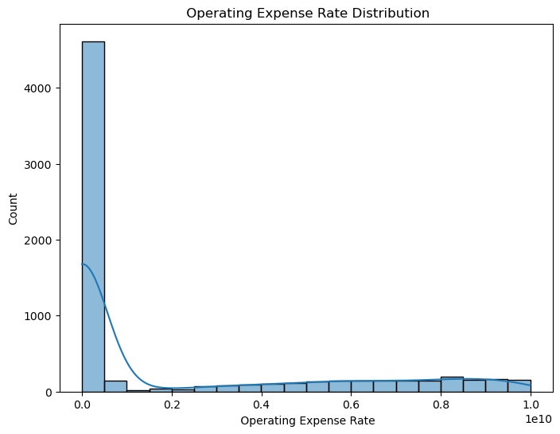

**Observation:**

* The histogram displays a right-skewed distribution of operating expense rates.
* Most data points cluster at lower rates, indicating effective expense management.
* Entities with rates near 0.0 are likely minimizing expenses efficiently.
* Fewer entities are observed as rates increase, suggesting varying expense management practices.
* This insight helps evaluate financial performance and operational efficiency.

**4.TOTAL ASSET GROWTH RATE DISTRIBUTION**

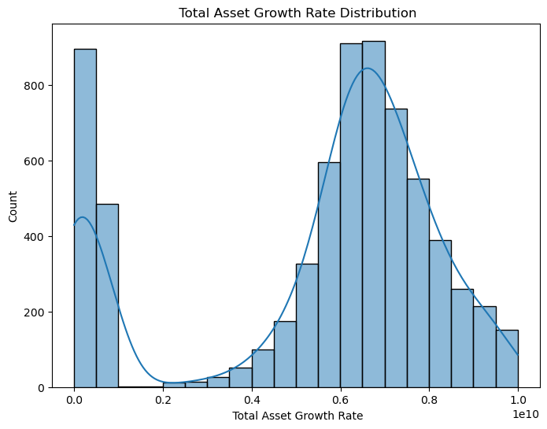

**OBSERVATION**

* The histogram displays a total asset growth rate distribution.
* The growth rate is peaking near 0.0 and 0.6
* Total asset growth rate distribution is inversely propotional to bankruptcy

**Transaction 1**

{

"Results": {

"WebServiceOutput0": [

{

"Bankrupt?": 1,

"Net Income to Total Assets": 0.716845343217827,

"Operating Profit Growth Rate": 0.848194994526472,

Operating Profit Rate": 0.998969203197885

"Equity to Long-term Liability": 0.126549487816618,

"Total debt/Total net worth": 0.0212659243655332,

"Net Income to Stockholder's Equity": 0.82789021403512,

"Interest Coverage Ratio (Interest expense to EBIT)": 0.564050112276341,

"Operating Expense Rate": 0.000125696868875964,

"Current Ratio": 0.002258963310566

"Cash Flow to Total Assets": 0.637555395323871,

"Scored Labels": 1,

"Scored Probabilities": 0.519323057306218

}

**Observations:**

* The model predicts bankruptcy with a probability of approximately 51.92%.
* The financial indicators suggest a relatively unstable financial situation, with a high debt ratio (20.76%) and low cash flow rate (45.81%).
* The company shows modest growth rates in various aspects, such as operating profit growth rate (84.82%) and after-tax net profit growth rate (68.90%).
* However, there are concerning signs such as a high interest expense ratio (62.99%) and high borrowing dependency (39.03%).
* The current ratio (0.23%) and quick ratio (0.12%) indicate a relatively weak liquidity position.

**Transaction 2**

{

"Bankrupt?": 1,

"Operating Expense Rate": 0.000289785053728762,

"Research and development expense rate": "0",

"Net Income to Stockholder's Equity": 0.839969268005573,

"Quick Assets/Total Assets": 0.127236002293688,

"Total debt/Total net worth": 0.0125023937843679,

"Operating Expense Rate": 0.000289785053728762,

"Equity to Long-term Liability": 0.120916105834965,

"Net Income to Stockholder's Equity": 0.839969268005573,

"Total debt/Total net worth": 0.0125023937843679,

"Cash Flow to Total Assets": 0.64109998470196,

"Current Ratio": 0.00601620587767277,

"Quick Ratio": 0.00403936682691048

"Operating Expense Rate": 0.000289785053728762,

"Interest Coverage Ratio (Interest expense to EBIT)": 0.570174946412453

"Scored Labels": 0,

"Scored Probabilities": 0.11806796432948005

},

**Observations:**

* This model predicts bankruptcy with a lower probability of about 11.76%.
* Financial indicators show improvements compared to Output 1, with a slightly lower debt ratio (17.12%) and higher cash flow rate (46.19%).
* Growth rates are consistent with Output 1, indicating stable but not exceptional performance.
* Liquidity ratios are slightly better than Output 1, with a current ratio of 0.60% and quick ratio of 0.40%.
* Overall, this output suggests a more stable financial situation compared to Output 1.

**Transaction 3**

{

"Bankrupt?": 1,

"Scored Labels": 0,

"Scored Probabilities": 0.24990627577514649

"Net Income to Total Assets": 0.774669696989803,

"Operating Profit Rate": 0.998857353483229,

"Equity to Long-term Liability": 0.117922319423666,

"Total debt/Total net worth": 0.0212476860084444,

"Net Income to Stockholder's Equity": 0.836774308550174,

"Interest Coverage Ratio (Interest expense to EBIT)": 0.563706076496047,

"Operating Expense Rate": 0.000236129720556318,

"Current Ratio": 0.0115425536893801,

"Quick Ratio": 0.00534756022243655,

"Cash Flow to Total Assets": 0.642764550242219,

}

**Observation:**

* The bankruptcy prediction probability for this output is approximately 24.86%.
* Financial indicators are similar to Output 1, with a debt ratio of 20.75% and a cash flow rate of 45.85%.
* Growth rates and liquidity ratios also align closely with Output 1.
* Notably, there is a significant difference in the research and development expense rate, which might indicate different business strategies or industry focus.
* Overall, while this output shares similarities with Output 1, the slightly lower bankruptcy prediction probability suggests a relatively better financial position.

**Conclusion:**

* Among the three outputs, Output 2 appears to offer the most favorable prediction with the lowest bankruptcy probability (11.76%).
* Output 2 also demonstrates relatively better financial indicators and liquidity ratios compared to Outputs 1 and 3.
* However, it's essential to consider additional factors and conduct further analysis before making a final decision on bankruptcy prediction.
* Overall, based on the provided information, Output 2 seems to be the best prediction model for bankruptcy.